Name: _______________
Period: _______________
Date: ________________

Stressed Out!
200 points

- Describe a time when you were totally stressed out.
- What made you stressed? (What type of stressor?)
- Did you feel changes happening in your body? (Physiological changes.)
- What did you do to overcome this stressor? (Or, what do you think you can do to overcome this stressor if it is still happening?)
- What can you do to prevent a stressful situation from happening again?
- Find one article online that deals with the effects of stress.
- Copy the link of the article and put on your page.
- Summarize the article.
- List 5 important facts that you found in the article.
- Reflect on one thing you have learned after doing this project.

  - Please answer using complete sentences
  - Approximately one paragraph per question (2-5 sentences)
  - Please type or print neatly!
  - Due today by the end of class
  - Scoring rubric located on the back of this page.

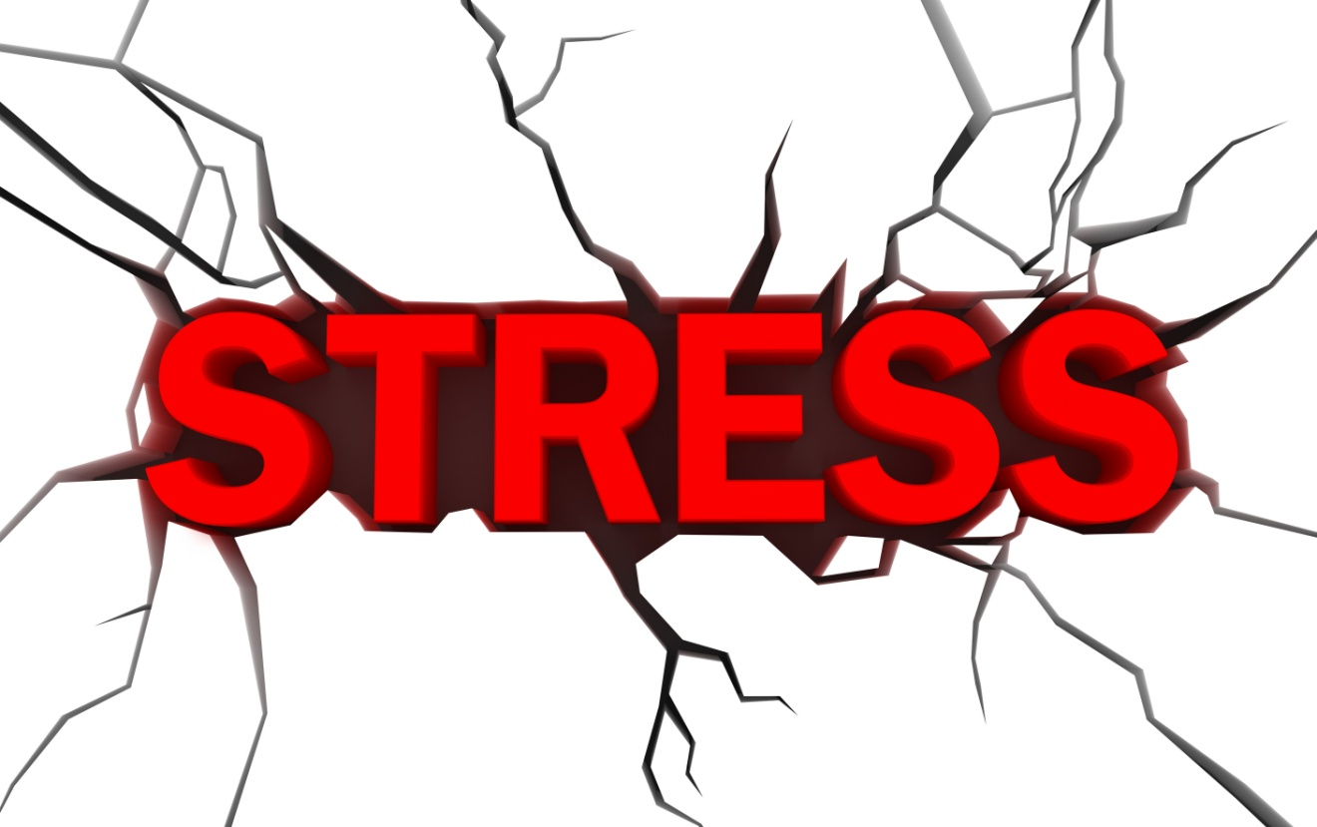

Evaluation Rubric:
Score | Content | Organization | Development | Use of Language
4 | Answers are appropriate to the questions. | Clear sense of order. Begins with a thesis or topic sentence. Supporting points are presented in a logical progression. | Develops each point with many specific details. Answers questions completely. | Uses technical or scientific terminology appropriately and correctly. No major grammatical or spelling errors.
3 | Answers are appropriate to the question. | May lack a thesis sentence, but points are presented in a logical progression. | Each point supported with some details and evidence. All important points included. | Accurate word choice. No more than 2 major errors and a few minor errors.
2 | Content relates to the question. | Points presented in a seemingly random fashion, but all support argument. | Sparse details or evidence. Questions only partially answered. | Ordinary word choice; use of scientific terminology avoided. Some serious errors (but they don’t impair communication).
1 | Content unrelated to question. | Lacks clear organizational plan. Reader is confused. | Statements are unsupported by any detail or explanation. Repetitious, incoherent, illogical development. | Limited vocabulary; errors impair communication.

