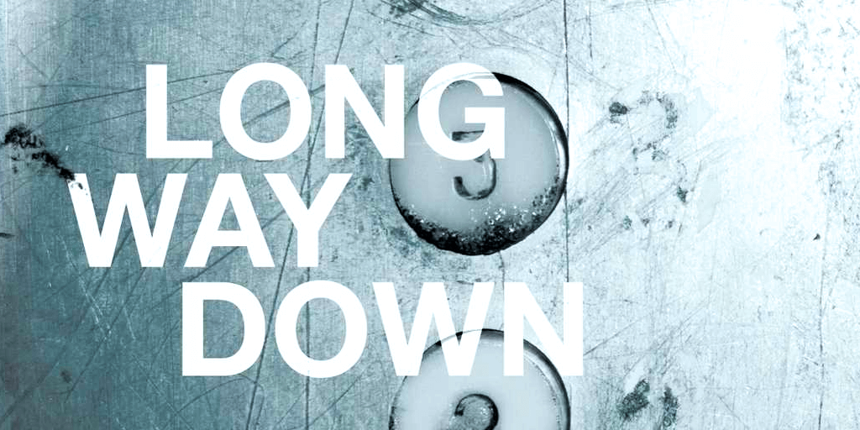
Long Way Down by Jason Reynolds – Final Essay

This is your final writing exam. It is worth 40 points summative. You will have class time on Monday and Tuesday to work on this one page response.

PAPERS WILL NOT BE ACCEPTED AFTER 3:00 ON WEDNESDAY.

Answer the question below in a short, but complete paragraph.
This will include:
- A complete Main Idea (Title, author and elaborated response)
- You must include at least 2 quotes with page numbers
- Your explanation must explain why the ideas in this book should be important to readers? Think about issues in the book like gun violence, revenge, what it means to be a “man,” etc. and then pick ONE to write about.)

What do you think Will decided to do at the end of the novel?

OR

Explain the ending of the novel.

Is the paragraph complete? Yes No
Does the writing use academic vocabulary? Yes No

1  (1 writing only does this.) | 2  (2 writing does 1 plus this.) | 3  (3 writing does 2 plus this.) | 4  (4 writing does 3 plus this.)
You have included a clear Main Idea that answers the question with specific explanation  You have support for your Thesis. | You have included specific evidence that is relevant to your Main Idea  You begin to explain your evidence. | Your explanations explicitly link back to your Main Idea and support all parts of it.  You explain your evidence with detail. Your writing shows that you have made some inferences to understand your subject. | You explain your evidence with detailed explanation that shows a deep understanding of your subject. It is evident that understanding goes beyond summary and shows use of inference.  You explain why the idea presented in your thesis should be important to your paper’s audience.
Expectations Checklist /10
Rubric /40
Total: /50

